**Project Planning Phase**

**Project Planning Template (Product Backlog, Sprint Planning, Stories, Story points)**

|  |  |
| --- | --- |
| **Date** | 6 JUNE 2025 |
| **Team ID** | LTVIP2025TMID34696 |
| **Project Name** | Enchanted Wings: Marvels Of Butterfly Species |
| **Maximum Marks** | 5 Marks |

**Product Backlog, Sprint Schedule, and Estimation (4 Marks)**

Use the below template to create product backlog and sprint schedule

| **Sprint** | **Functional Requirement (Epic)** | **User Story Number** | **User Story / Task** | **Story Points** | **Priority** | **Team Members** |
| --- | --- | --- | --- | --- | --- | --- |
| Sprint-1 | Data Collection & Preprocessing | USN-1 | As a developer, I want to collect butterfly images and labels from a dataset (CSV + image folders). | 3 | High |  |
| Sprint-1 | Data Collection & Preprocessing | USN-2 | As a developer, I want to preprocess image data and load it efficiently using ImageDataGenerator. | 3 | High |  |
| Sprint-2 | Model Development | USN-3 | As a data scientist, I want to build a butterfly classifier using VGG16 and Transfer Learning. | 4 | High |  |
| Sprint-2 | Model Evaluation | USN-4 | As a data scientist, I want to validate model accuracy using test data and classification metrics. | 3 | Medium |  |
| Sprint-3 | Web Deployment & API Integration | USN-5 | As a user, I want to upload a butterfly image and view species prediction through a web interface. | 4 | High |  |
| Sprint-3 | Visualization & User Interface Integration | USN-6 | As a developer, I want to display prediction results neatly on a Flask-based HTML page. | 3 | High |  |
| Sprint-4 | Visualization & Use Case Integration | USN-7 | As a developer, I want to deploy the model, create APIs, and host the project for user access. | 3 | Medium |  |
| Sprint-4 | Visualization & Use Case Integration | USN-8 | As a student, I want to provide biodiversity awareness through species information after prediction. | 3 | High |  |

**Project Tracker, Velocity & Burndown Chart: (4 Marks)**

| **Sprint** | **Total Story Points** | **Duration** | **Sprint Start Date** | **Sprint End Date (Planned)** | **Story Points Completed (as on Planned End Date)** | **Sprint Release Date (Actual)** |
| --- | --- | --- | --- | --- | --- | --- |
| Sprint-1 | 6 | 5 Days | June 1,2025 | June 5,2025 | 6 | June 5,2025 |
| Sprint-2 | 7 | 5 Days | June 1,2025 | June 5,2025 | 7 | June 5,2025 |
| Sprint-3 | 7 | 5 Days | June 1,2025 | June 5,2025 | 7 | June 5,2025 |
| Sprint-4 | 6 | 5 Days | June 1,2025 | June 5,2025 | 6 | June 5,2025 |

**Velocity:**

Imagine we have a 10-day sprint duration, and the velocity of the team is 20 (points per sprint). Let’s calculate the team’s average velocity (AV) per iteration unit (story points per day)



**Burndown Chart:**

A burn down chart is a graphical representation of work left to do versus time. It is often used in agile[software development](https://www.visual-paradigm.com/scrum/what-is-agile-software-development/) methodologies such as [Scrum](https://www.visual-paradigm.com/scrum/scrum-in-3-minutes/). However, burn down charts can be applied to any project containing measurable progress over time.

**<https://www.visual-paradigm.com/scrum/scrum-burndown-chart/>**

**<https://www.atlassian.com/agile/tutorials/burndown-charts>**

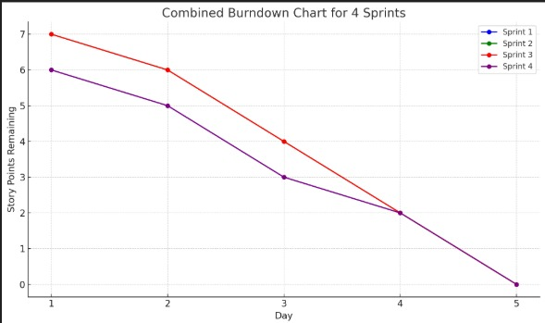

**Reference:**

**<https://www.atlassian.com/agile/project-management>**

**<https://www.atlassian.com/agile/tutorials/how-to-do-scrum-with-jira-software>**

**<https://www.atlassian.com/agile/tutorials/epics>**

**<https://www.atlassian.com/agile/tutorials/sprints>**

**<https://www.atlassian.com/agile/project-management/estimation>**

**<https://www.atlassian.com/agile/tutorials/burndown-charts>**